- Architecture diagram image: Linear Pipeline

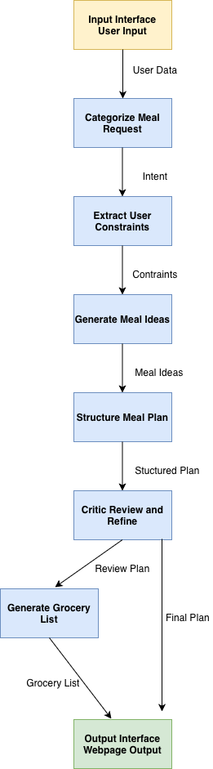
Tools used: LLM(text generation via opal), NLP (constraint extraction and classification), Rule-based logic (planning and grocery list), HTML (final output)
- Design document:
The system consists of 6 core agents supported by two interfaces which are the opal input interface where the user provides data and the opal output interface where the final results are presented.
The OPAL input interface collects the user’s meal preferences, dietary restrictions, available ingredients and time constraints. Then this data is passed to the first agent, Categorize Meal Request which determines the user’s intent, classifying it as a quick meal, a few meal options or a full multi-day meal plan.
The Extract User Constraints agent then processes the input and intent to identify key details such as cooking time, available ingredients, dietary restrictions, nutritional goals, and the number of meals needed. If any information is missing the agent makes reasonable assumptions to maintain practicality, prioritizing quick, simple and healthy meals
Next, the Generate Meal Ideas agent creates one or multiple meal suggestions based on the extracted constraints. Quick meals produce single suggestion, multiple meal options produce two or four suggestions, and a full meal plan produces a complete set of meals for the specified days. All meals designed to be realistic, balanced and easy to prepare.
The Structured Meal Plan agent formats the meal ideas into a structured schedule or organized list. For full meal plans, meals are assigned to breakfast, lunch and dinner slots while ensuring variety and avoiding repetition. For quick meals or options, the output is a clear, readable list.
The Critic Review and Refine agent evaluates the meal plan for feasibility, nutritional balance and flavor. It analyzes preparation time, ingredient usage, and potential issues, excessive protein quantities or repetitive meals. The critic suggests improvements, seasoning adjustments, side dish recommendations or balancing protein content based on the user’s goals.
After review, the Generate Grocery List agent consolidates ingredients from all meals into categories such as produce, proteins, grains, dairy and other. Duplicate ingredients are merged producing a clear shopping list if needed. Finally, the OPAL output interface presents the critic reviewed meal plan and grocery list as a responsive webpage, providing a clean, modern and accessible design for the user.
The workflow is a liner pipeline with data passing sequentially between agents as stated previously.
Failure handling :
The critic agent serves as the quality gatekeeper, ensuring meal plans meet user constraints and practical cooking considerations. When issues such as excessive ingredient quantities, poor flavor balance or impractical preparation steps are detected, the Critic documents these in its review. The system notifies the user who can then revise input or restart. This approach ensures that only well evaluated plans are presented. In future versions, a feedback loop could be implemented to allow the critic agent to directly trigger meal regenerations for continuous improvement.

- Updated code with multi-agent workflow implemented ( I am using Opal, so I provided the prompts for each agent as instructed.)

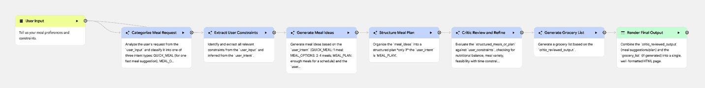
- Opal user input

- Categorize Meal Request
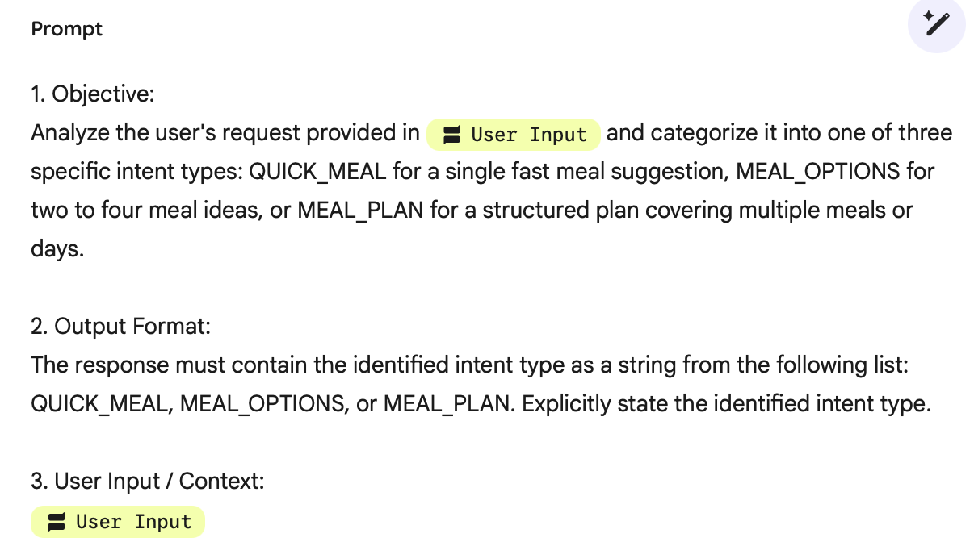

- Extract User Constraints
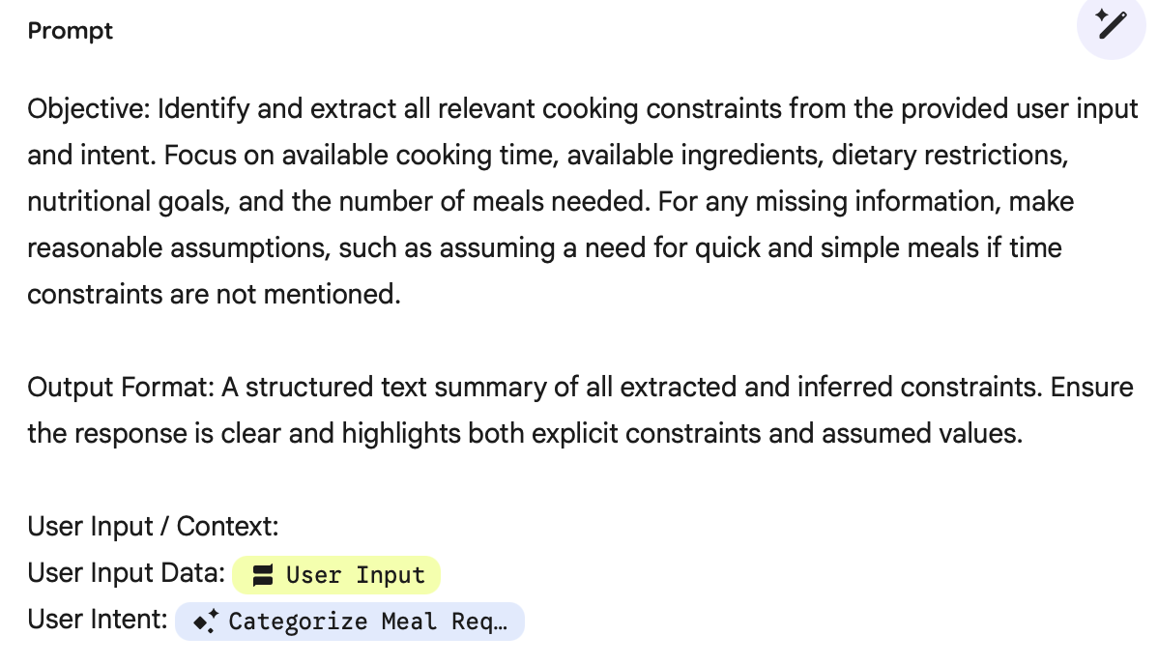
- Generate Meal Ideas 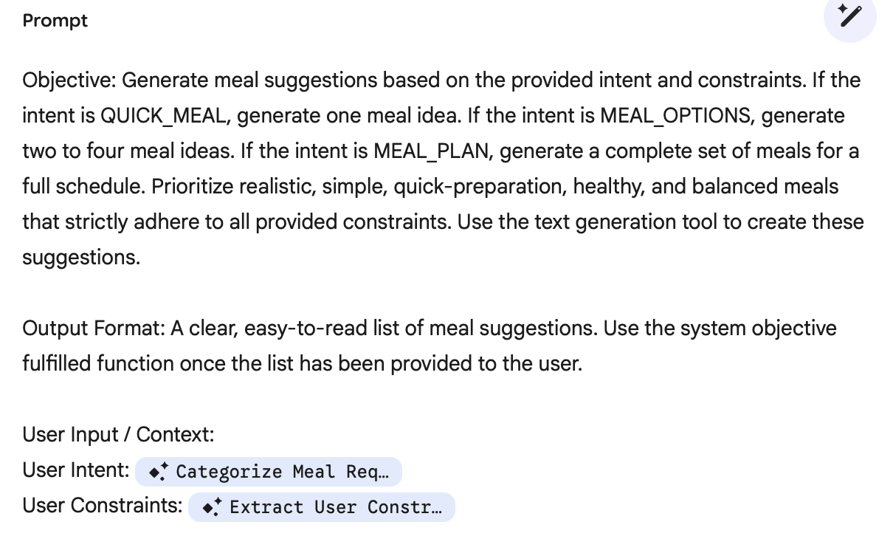

- Structure Meal Plan
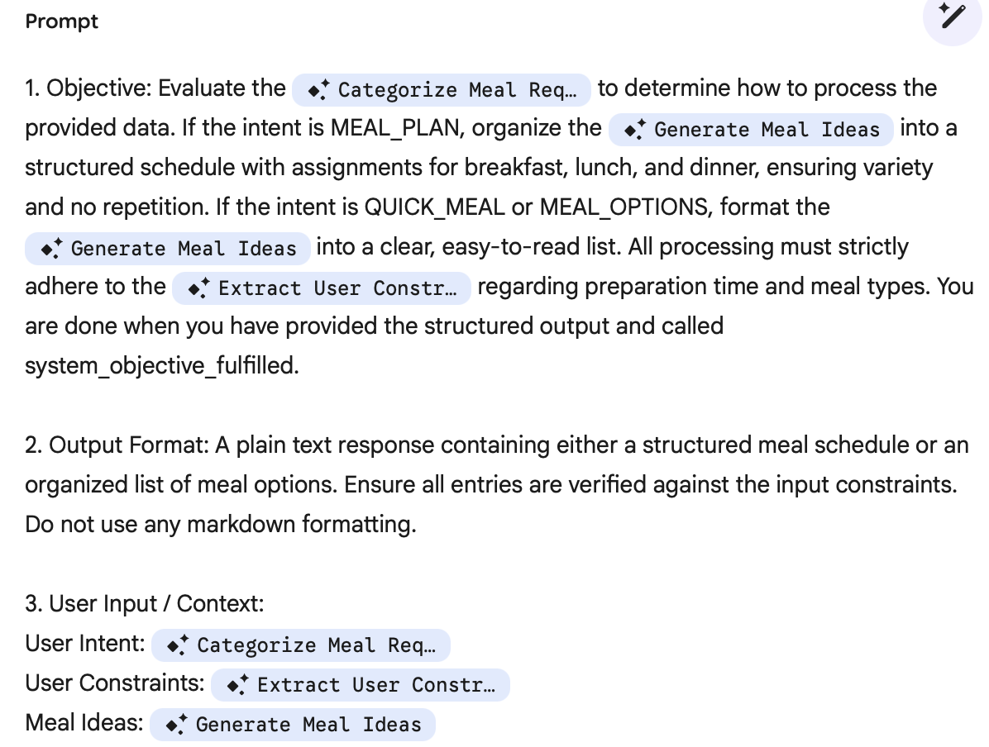
- Critic Review and Refine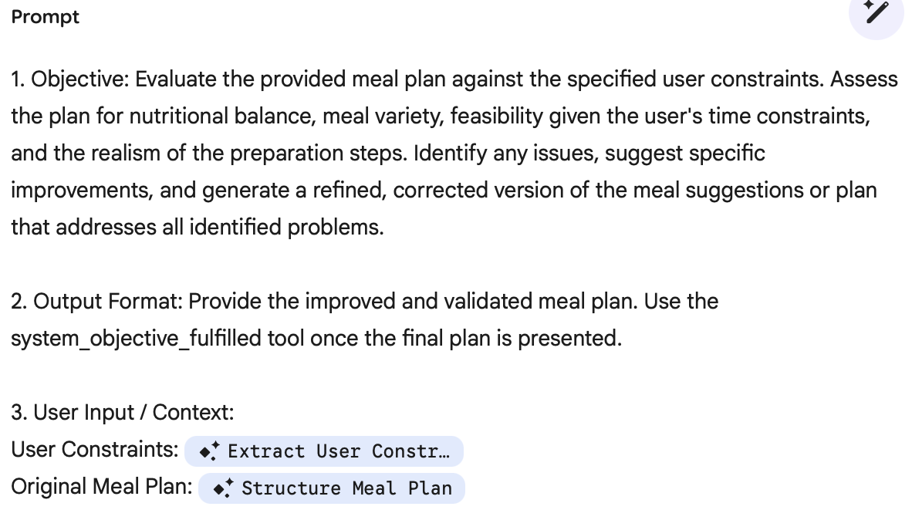

- Generate Grocery List
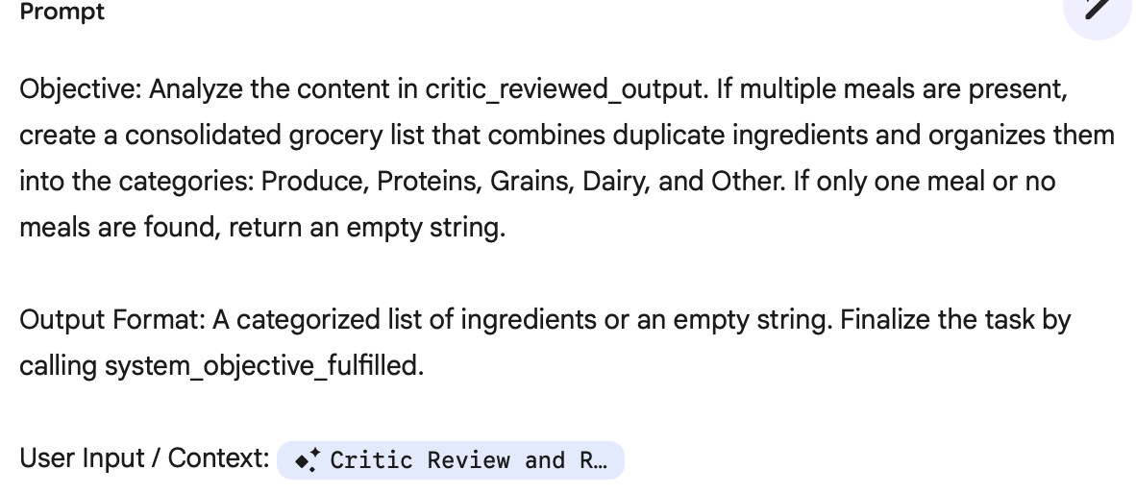

- Opal final output

In Class Activity

Develop a plan for addressing agentic system risks in the agentic system you are developing as part of the project.
Risk | Mitigation Plan
 | Design & development of agent | Agent integration into processes
Adversarial attacks | Test model against tricky inputs and add checks | monitor outputs, alert human if suspicious
Bias and discrimination | Use diverse data, check fairness | Keep an eye on decisions and let humans review
Misinformation and hallucinations | Teach model to fact check and reduce fake info | Flag unsure answers, human review for important stuff
Data privacy violations | Encrypt data and avoid sensitive info | Follow privacy laws, get consent and delete data when needed
Intellectual property risks | Use licensed data and track sources | Warn users about copyright and check outputs

